W E E K 5 T A S K

Predictive Modeling and Algorithm Selection
Predicting unhappy customers in skincare: facewashes, acne serums and a spot patch

Submitted by: Vishakha Bisht
Data Science with Python Analyst Internship in Coimbatore

Contents
- Summary
- From the Business Problem to Prediction Tasks
- Candidate Models: Description, Strengths and Weaknesses
- Evaluation Metrics and Expected Performance
- Results on Real Data
- Validation and Robustness Plan
- Pitfalls: Overfitting, Underfitting and Leakage
- Interpreting Model Outcomes for the Business
- Limitations and Next Steps References
Appendix: Files and Environment

Summary
Week 1 asked why skincare customers become unhappy. Weeks 3 and 4 cleaned and explored real Sephora reviews (140,435 reviews, 98 products) and engineered features. This week turns that into a modelling strategy: which prediction tasks serve the business, which algorithms fit them, how to measure and validate them, and how to read the results. Unlike a plan on paper, every model below was trained and tested on the real data, so each choice is backed by a number. All results come from w5_models.py (appendix).

Task | Best model | Result (cross-validated, products held out) | Baseline to beat
1. Flag a review that will be 1 to 2 stars (classification) | Gradient boosting on structured + text features | ROC AUC 0.889 ± 0.002; PR AUC  0.514 ± 0.023; held-out test  AUC 0.890 | AUC 0.50; PR AUC 0.10  (the share of 1 to 2 star reviews)
2. Predict the star rating (regression) | Gradient boosting | RMSE 0.892 stars, MAE 0.636,  R² 0.37 | Mean baseline RMSE 1.123
3. Group products by complaint profile (clustering) | k-means, k = 5 | Silhouette 0.23, stability (ARI) 0.83 | Silhouette at k=2: 0.16
4. Forecast the monthly share of 1 to 2 star reviews (trend) | Linear trend | RMSE 0.024 (a 12%  improvement over the naive forecast) | Naive RMSE 0.027

Three honest points. (1) Words carry most of the signal: with structured features only, the best AUC is 0.70; adding text features lifts it to 0.89. (2) One feature, helpful votes, raised AUC from 0.889 to 0.911 but is not known when a review is posted, so it was excluded (Section 7). (3) The data has one patch product, so patch conclusions are a case study.

From the Business Problem to Prediction Tasks

Why prediction matters in this market
India’s beauty and personal care market was reported at Rs. 74,557 crore in 2026, up from Rs. 59,351.96 crore a year earlier, and the organic personal care segment alone was valued at US$ 1.1 billion in 2025 with a forecast of US$ 3.0 billion by 2034 (CAGR 10.76%) (IBEF, 2026, citing IMARC Group). Quick-commerce platforms now bring more than 30 million monthly shoppers to beauty and personal care (IBEF, 2026), and NielsenIQ has described India as the fastest-growing online market for beauty products (Economic Times, NielsenIQ report). Online selling means products are judged in public reviews within days of launch. A brand that can spot unhappy customers early, and know why, can fix a pack claim or a formula before ratings settle. Regulation adds pressure: the Ecomark scheme (2024) and the Cosmetics Rules, 2020 require "natural" and "organic" claims to be justified (IBEF, 2026), which makes ingredient-level, evidence-based decisions more valuable.

Linking the Week 1 problem to modelling tasks

Business question (Week 1) | Prediction task | Target and type | Algorithms considered
Which reviews signal an unhappy customer that care teams should see first? (RQ1) | Classify a review as 1 to 2 stars before anyone reads it | low_rating (0/1), imbalanced: 9.8% positive. Classification | Logistic regression, decision tree, random forest, gradient boosting
How satisfied will customers be with a product? (RQ2, RQ5) | Predict the star rating of a review | rating (1 to 5). Regression | Linear and ridge regression, random forest, gradient boosting
Which products fail in the same way? (RQ3, H3) | Group products by complaint profile | No target. Clustering | k-means (with PCA to display)
Is dissatisfaction rising? (market trend) | Forecast monthly low-rating share | Monthly share. Time-series forecast | Naive, moving average, linear trend, seasonal naive

Why a review-level classifier first: it is the step that every later analysis (reason labelling, ranking, alerts) depends on, it has a clear business use (triage), and it can be tested on a large sample. The other three tasks answer different questions and are kept short.

Data and set-up

Item | Detail
Data | Real Sephora reviews and product table (Kaggle); features from the Week 4 pipeline (real_eda.py)
Size | 140,435 reviews, 98 products. Target prevalence 9.8%
Split | By product, never by review: train 111,209 reviews (74 products), test 29,226 (24 unseen products). The test set is used once, after model choices
Features | 48 in total: 35 structured (type, skin type, price, ingredients, actives, length, time) and 13 text (sentiment counts, negations, keyword flags). The vote count was excluded as leakage
Why split by product | Reviews of the same product share traits (price, ingredients, brand). A random split would put them on both sides and make the model look better than it is on new products

Candidate Models: Description, Strengths and Weaknesses
Six model families were compared. The first two are described in detail because they are the main candidates; the rest are described briefly. Every model is from scikit-learn (Pedregosa et al., 2011).

Logistic regression (the interpretable baseline)
How it works. The model computes a weighted sum of the features, passes it through the sigmoid function and returns a probability between 0 and 1. Each weight is a log-odds change per unit of the feature; with standardised features, exp(weight) is the odds ratio per one standard deviation.
Worked example from this data. One more standard deviation of positive words multiplies the odds of a 1 to 2 star review by 0.33 (a 67% cut). One more standard deviation of negation words ("not", "never") multiplies it by 1.55, and of "not effective" phrases by 1.38.

    - Strengths: fast (1.4 seconds for 5 folds), stable, probabilities are usable, coefficients explain themselves, hard to overfit. Strong with the text features: AUC 0.871.
    - Weaknesses: assumes the log-odds are linear in each feature and cannot find interactions on its own (such as retinoid and sensitive skin together), so it falls behind boosting when structured features are used alone.
    - Settings used: StandardScaler, class_weight = balanced (because only 10% of reviews are positive), L2 penalty.

Gradient boosting (the accuracy candidate)
How it works. Many shallow decision trees are built one after another; each new tree fits the mistakes (gradients of the loss) left by the earlier ones, and the predictions are added with a small learning rate (Friedman, 2001). scikit-learn’s HistGradientBoosting bins the features into histograms, which makes training on more than 100,000 rows fast.
def clf_models(): return {
'Logistic regression': make_pipeline(StandardScaler(), LogisticRegression(max_iter=3000, class_weight='balanced')),
'Decision tree (depth 6)': DecisionTreeClassifier(max_depth=6, min_samples_leaf=50, class_weight='balanced', random_state=SEED),
'Random forest': RandomForestClassifier(n_estimators=120, max_depth=14, min_samples_leaf=20, max_samples=0.3, class_weight='balanced_subsample', n_jobs=-1, random_state=SEED),
'Gradient boosting': HistGradientBoostingClassifier(max_depth=5, learning_rate=0.06, max_iter=200, l2_regularization=1.0, random_state=SEED),
}

    - Strengths: finds non-linear effects and interactions automatically, handles features on any scale, the best score of all models here (AUC 0.889, PR AUC 0.514), and it is the best calibrated model (Brier score 0.063 on test vs 0.142 for logistic regression with balanced weights).
    - Weaknesses: can overfit if left to run (training AUC reaches 0.95 against a validation AUC of 0.89 after 400 iterations, Section 7); less transparent than logistic regression; more settings to tune.
    - Settings used: max_depth = 5, learning_rate = 0.06, 200 iterations, L2 regularisation 1.0.

Other candidates, in brief

Model | Strengths for this problem | Weaknesses for this problem
Decision tree (depth 6) | Rules a manager can read ("if negations above 2 and positive words below 1 then high risk"); no scaling needed | Unstable; deep trees memorise (Section 7); lowest scores here (AUC 0.861)
Random forest (Breiman, 2001) | Averages many trees, so more stable than one tree; AUC 0.881; works with little tuning | Slower and less accurate than boosting here; probabilities are less well calibrated
Linear / ridge regression | Simple rating model with an interpretable equation; RMSE 0.947 | Cannot capture non-linear effects; ridge adds nothing here because features are few and data is large (RMSE 0.947)
k-means clustering | No labels needed; groups products by complaint profile; fast | Needs k chosen; assumes round clusters; sensitive to scaling and outliers (the patch is an outlier)
Time-series baselines | Transparent; tested honestly with a rolling origin | Only 48 monthly points; no seasonality found, so complex models (ARIMA, Prophet) are not justified

Choice of model and reasons
    - Production candidate: gradient boosting, because it has the best discrimination, the best calibration and a small spread across folds.
    - Reporting and explanation model: logistic regression, because the odds ratios can be shown to non-technical teams, and its AUC (0.871) is only 0.018 below boosting.
    - Not chosen: a deep neural network or a transformer. The features are small tabular data and 48 columns; the gain over boosting would be small and the explanation cost high. A transformer on the review text is a planned next step, once labelled reasons exist.

Evaluation Metrics and Expected Performance

Which metric, and why
Why accuracy is not used. Only 10.0% of test reviews are 1 to 2 stars. A model that always predicts "not unhappy" is 90.0% accurate and finds no unhappy customer. So accuracy is reported only to show this trap.

Metric | What it measures | Use and limits in this project
ROC AUC | Chance that a random unhappy review scores higher than a random happy one (0.5 is chance) | Main ranking metric; independent of threshold; can look flattering when positives are rare
PR AUC (average precision) | Precision averaged over all recall levels | Primary metric for imbalance; the random baseline equals the positive share (0.10), so 0.51 is about 5 times better (Saito & Rehmsmeier, 2015)
Precision | Of the reviews flagged, the share that are truly unhappy | Controls wasted care-team effort
Recall | Of all unhappy reviews, the share found | Controls missed customers; the business sets the target (for example 70%)
F1 | Harmonic mean of precision and recall | One number for threshold choice; hides the trade-off, so the curve is shown too
Brier score and calibration plot | Whether a predicted 30% really means about 30% | Needed if probabilities drive decisions (Niculescu-Mizil & Caruana, 2005)
RMSE, MAE, R² | Average error of the rating prediction, in stars; share of variance explained | RMSE punishes large misses; MAE is easier to explain; R² compared with the mean baseline
Silhouette, ARI | How well separated clusters are (-1 to 1); how stable they are across random starts | Used to pick k and to check the clusters are not an accident of the random seed
Forecast RMSE / MAE | Error of the next-month forecast | Evaluated with a rolling origin (Hyndman & Athanasopoulos, 2021), never with a random split

Worked example: reading a confusion matrix
At the F1-optimal threshold (0.26) the gradient boosting model on the held-out 24 products gives: true positives 1,667, false positives 1,817, false negatives 1,262, true negatives 24,480. Precision = 1667 / (1667 + 1817) = 0.478. Recall = 1667 / (1667 + 1262) = 0.569. F1 = 0.520. In words: about one
flag in two is right, and the model finds about 57% of unhappy reviews.

Expected versus observed performance
Expectations for the classifiers come from the Week 4 experiments on the same features (AUC 0.51 for raw columns, 0.67 to 0.73 with engineered structured features, 0.87 to 0.89 with text features). The expectations for the rating model and the forecast are judgement-based, so those two rows are weaker evidence.

Model and feature set | Expected (from Week 4) | Observed (CV) | Verdict
Classifiers on structured features only | AUC 0.65 to 0.75 (Week 4) | AUC 0.67 to 0.70 | In range
Classifiers with text features | AUC 0.85 to 0.90 | AUC 0.86 to 0.89 | In range
Boosting vs logistic regression (text) | Boosting about 0.01 to 0.03 higher | 0.018 higher | In range
Rating regression | RMSE about 0.85 to 0.95 | RMSE 0.89 to 0.95 | In range
Trend forecast | Small gain over naive | 0.024 vs 0.027 | Small gain, as expected

Results on Real Data

Classification: flagging 1 to 2 star reviews

Model | ROC AUC (CV) | PR AUC (CV) | Test AUC | Test PR AUC
Logistic regression, structured only | 0.665 ± 0.016 | 0.154 ± 0.010 | 0.682 | 0.167
Decision tree (depth 6), structured only | 0.661 ± 0.022 | 0.157 ± 0.016 | 0.687 | 0.164
Random forest, structured only | 0.691 ± 0.019 | 0.173 ± 0.016 | 0.711 | 0.190
Gradient boosting, structured only | 0.697 ± 0.006 | 0.182 ± 0.013 | 0.724 | 0.201
Logistic regression, structured + text | 0.871 ± 0.006 | 0.441 ± 0.014 | 0.874 | 0.486
Decision tree (depth 6), structured  + text | 0.861 ± 0.006 | 0.407 ± 0.020 | 0.857 | 0.431
Random forest, structured + text | 0.881 ± 0.004 | 0.474 ± 0.019 | 0.877 | 0.509
Gradient boosting, structured + text | 0.889 ± 0.002 | 0.514 ± 0.023 | 0.890 | 0.548
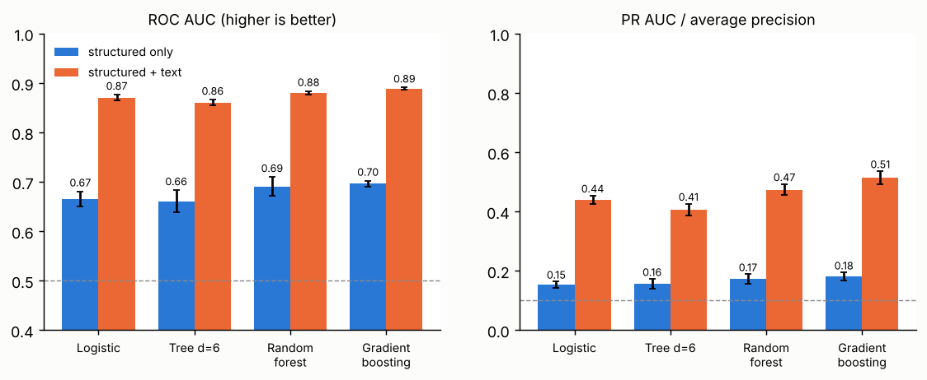
Figure 1. Cross-validated ROC AUC and PR AUC (error bars: standard deviation over 5 product-grouped folds; dashed line: no-skill baseline)

    - Adding text features lifts boosting from 0.70 to 0.89 AUC and from 0.18 to 0.51 PR AUC. Product facts alone, such as price and ingredients, say little about whether a particular review is negative.
    - The ranking of models is the same in cross-validation and on the held-out products (boosting > random forest > logistic regression > tree with text features), which supports the choice.
    - The differences between boosting and random forest (0.008 AUC) are about three times the fold spread (about 0.003), so they are real but small.

Choosing a threshold from the business cost
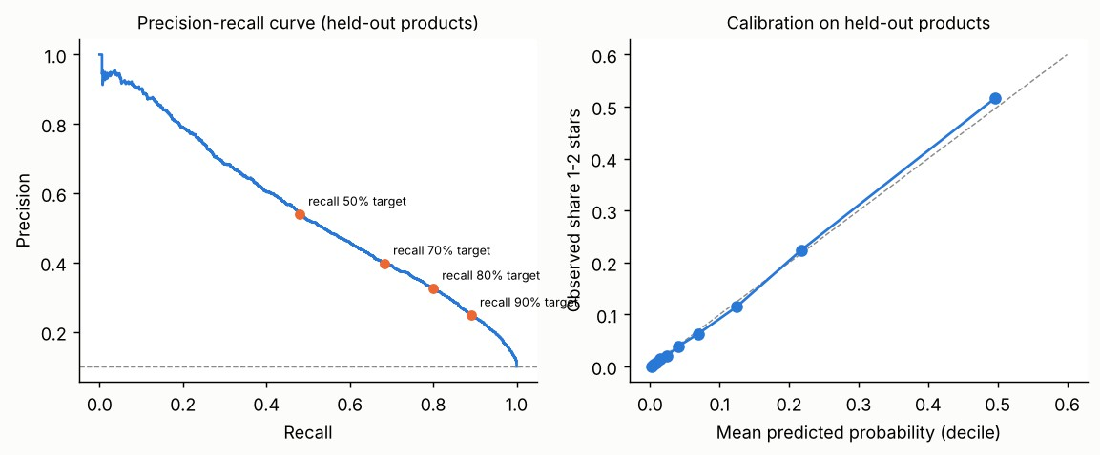
Figure 2. Precision-recall trade-off and calibration on the held-out products

Recall target (set on CV) | Threshold | Test precision | Test recall | Reviews flagged
50% | 0.32 | 0.540 | 0.480 | 8.9%
70% | 0.19 | 0.398 | 0.683 | 17.2%
80% | 0.13 | 0.326 | 0.800 | 24.6%
90% | 0.06 | 0.249 | 0.891 | 35.8%
The threshold was chosen on out-of-fold predictions from the training products and then applied to the test products. The achieved recall matches the target closely (for example target 70%, test 68.3%), which shows the threshold transfers to new products. Predicted probabilities follow the diagonal in the calibration plot, so a score of 0.5 means about one in two. Business choice: a care team that can read 17% of reviews catches about 68% of the unhappy ones, at a precision of about 40%.

Regression: predicting the star rating
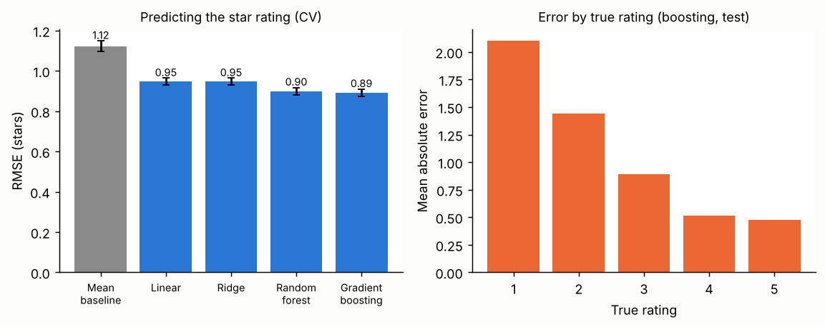
Figure 3. Rating prediction error (left) and mean absolute error by true rating (right)

Model | RMSE (CV) | MAE (CV) | R² (CV) | Test RMSE
Mean baseline | 1.123 ± 0.026 | 0.874 | -0.00 | 1.130
Linear regression | 0.947 ± 0.017 | 0.686 | 0.29 | 0.953
Ridge (alpha 10) | 0.947 ± 0.017 | 0.686 | 0.29 | 0.953
Random forest | 0.899 ± 0.018 | 0.640 | 0.36 | 0.903
Gradient boosting | 0.892 ± 0.018 | 0.636 | 0.37 | 0.898

Gradient boosting reduces the error by 21% compared with always predicting the mean, and explains about 37% of the variation. The error depends strongly on the true rating: 2.10 stars for 1-star reviews but 0.48 for 5-star reviews, because the model regresses towards the dominant 5-star class. For this reason the classification framing (Section 5.1) is better for finding unhappy customers, and the rating model is better for ranking products.

Clustering: products with similar complaint profiles
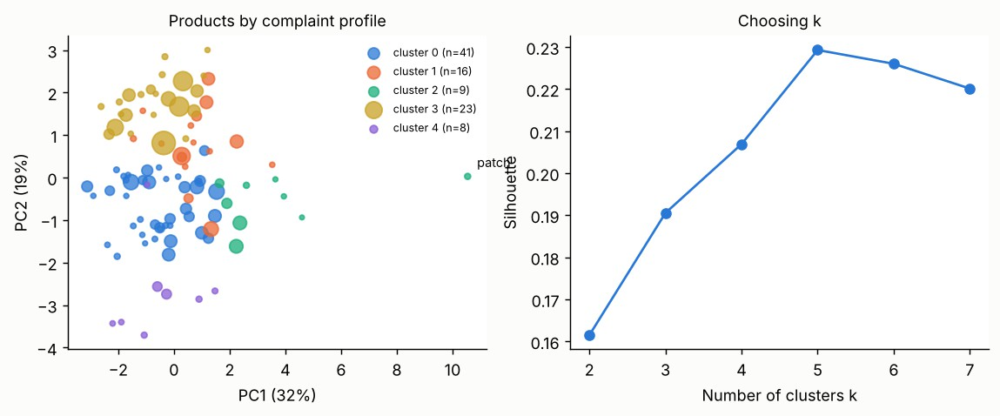
Figure 4. Products in the first two principal components (bubble size: number of reviews) and silhouette score by k

Cluster (name given after inspection) | Products | Low-rating share | Irritation words | Other signal | Reading
0. Premium serums, few complaints | 41 | 6.7% | 15% | price about  $66 | Healthy segment
1. Lower-priced cleansers with breakout reports | 16 | 10.1% | 17% | breakouts 23% | Possible pore-clogging formulas
2. Efficacy-doubted products (includes the patch) | 9 | 21.9% | 13% | "not effective" 11% | Weakest ratings (mean 3.83); fix the claim
3. Fragranced cleansers | 23 | 9.1% | 14% | smell mentions 46% | Scent is discussed, not penalised
4. Retinoid products | 8 | 6.4% | 29% | retinoid 88% | Highest irritation words but few low ratings

The silhouette peaks at k = 5 (0.23), and the clusters are stable across random starts (adjusted Rand index 0.83). The silhouette is modest (below 0.25), so the groups are tendencies, not sharp types. Two findings agree with Week 4: efficacy complaints drive the weakest cluster, and retinoid products draw irritation words (29%) while keeping a low rate of 1 to 2 star ratings (6.4%), so irritation alone does not make a customer unhappy.

Forecasting the trend

Method (one-month-ahead) | RMSE | MAE | Comment
Naive (last month) | 0.027 | 0.020 | Baseline
3-month moving average | 0.027 | 0.020 | About the same as naive
Linear trend | 0.024 | 0.019 | Best, by 12%
Seasonal naive (same month last year) | 0.036 | 0.026 | Worst: no yearly pattern

The series covers 48 months (2019-01 to 2022-12); the first 24 were used to start the models and the last 24 were forecast one month at a time (rolling origin). The mean monthly share of 1 to 2 star reviews is 10.1% with a standard deviation of 3.0%, so the best forecast error (2.4%) is smaller than the natural month-to-month swing but only a little better than the naive forecast. This is why simple methods were kept.

Validation and Robustness Plan

Step | What is done | Result here
1. Split by product | Hold out whole products (24 of 98) as the final test, touched once | Test AUC 0.890 vs CV 0.889
2. Grouped k-fold on the training products | 5-fold GroupKFold so a product is never in training and validation together | Fold SD of AUC is 0.002 to 0.006
3. Baselines first | Mean rating, always-negative classifier, naive forecast | Every model beats them (Section 5)
4. Leakage audit | List each feature and ask whether it exists at prediction time | Vote count removed (Section 7)
5. Learning and validation curves | Train vs validation score against model complexity | Tree depth 7 and boosting early stop (Section 7)
6. Calibration and threshold transfer | Calibration plot; threshold set on CV, applied to test | Close to the diagonal; recall target met

Step | What is done | Result here
7. Stability | Clusters re-run with 5 seeds (ARI); importance with 5 shuffles | ARI 0.83; importance SD below 0.003
8. Subgroup check | Product-level correlation between predicted and observed low-rating share on unseen products | Spearman ρ = 0.78 across 24 products
9. Time check (planned) | Train on older reviews, test on newer ones | Needed before deployment; not run because only one date range was available

The decision threshold is picked on out-of-fold predictions (from the grouped cross-validation) and only then applied to the unseen test products. This order is the main protection against over-optimistic results:
pr, rc, th = precision_recall_curve(tr.low_rating.values, oof[best]) rows = []
for target_recall in [0.5, 0.7, 0.8, 0.9]:
i = np.where(rc[:-1] >= target_recall)[0][-1]; t_ = th[i] pt = test_p[best]; yhat = (pt >= t_).astype(int)
rows.append({'target_recall_cv': target_recall, 'threshold': float(t_), 'cv_precision': float(pr[i]), 'test_precision': float(precision_score(te.low_rating, yhat)),
'test_recall': float(recall_score(te.low_rating, yhat)), 'test_f1': float(f1_score(te.low_rating, yhat)), 'flagged_share_test': float(yhat.mean())})
RES['thresholds'] = rows

Hyperparameters were fixed at sensible values rather than tuned heavily, because the validation curves (Section 7) show the scores are flat near the chosen settings. If tuning is added, it must be nested inside the training folds so the test products stay untouched (Cawley & Talbot, 2010).

Pitfalls: Overfitting, Underfitting and Leakage
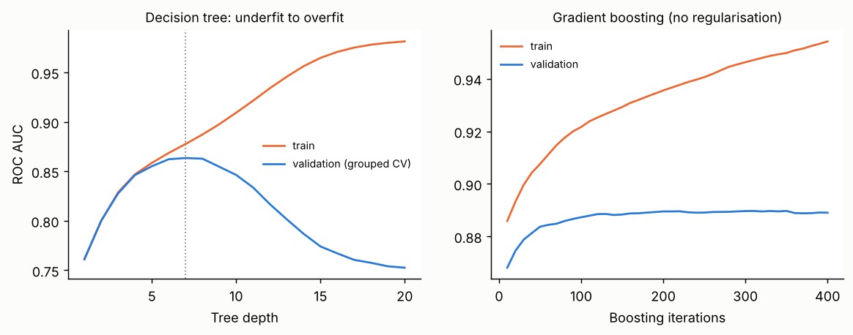
Figure 5. Left: a single decision tree under- and over-fits as depth grows. Right: gradient boosting with no regularisation keeps improving on training data while validation stalls

Problem | Evidence from this data | Mitigation used or planned
Underfitting | A tree of depth 1 reaches CV AUC 0.761, far below the best 0.863 | Add depth or features; the engineered text features moved the best model from about 0.70 to 0.89
Overfitting (tree) | At depth 20 training AUC is 0.981 but validation AUC falls to 0.753 (gap 0.23); best depth is 7 | Limit depth (6 used), minimum leaf size 50, pruning

Problem | Evidence from this data | Mitigation used or planned
Overfitting (boosting) | After 400 iterations train AUC 0.954 vs validation 0.889; validation peaks near iteration 350 | Small learning rate, depth 5, L2 regularisation, 200 iterations, early stopping when adding data
Class imbalance | Only 9.8% of reviews are positive | class weights, PR AUC, threshold chosen on business cost; resampling kept as an option
Product leakage | Reviews of one product look alike | Group-aware splits (Section 6)
Target leakage | Helpful votes: mean log-votes 1.57 for 1 to 2 star reviews vs 0.65 for the rest. With votes, test AUC is 0.916 vs 0.890 without | Remove features that appear after posting (votes, later product totals)
Label noise and circularity | Keyword flags are rules built from the same words the model sees; the star rating is a noisy proxy for "unhappy" | Human-labelled sample; report text features separately from structured ones
Distribution shift | Review volume grew about 40 times from 2008 to 2022 | Time-split test and periodic retraining

Worked example of leakage. In the first run, helpful votes were the most important feature (shuffling it cut AUC by 0.055), and structured features alone reached AUC 0.805. The reason is simple: unhappy reviews attract more votes, but votes arrive days after a review is posted. A triage system must decide at posting time, so the feature was removed and the structured-only AUC dropped to 0.697. Keeping it would have inflated the headline number by 0.022 for the combined model and 0.11 for the structured model.

Interpreting Model Outcomes for the Business
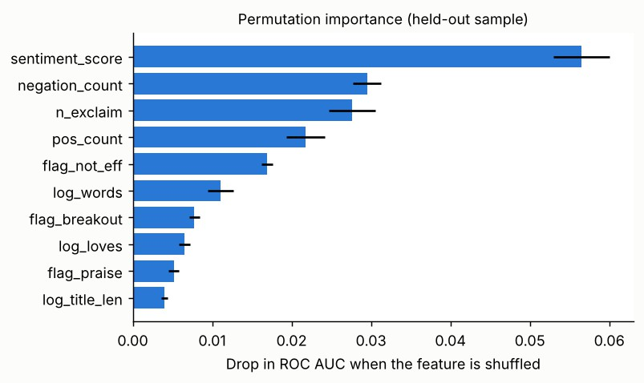
Figure 6. Permutation importance on held-out reviews (gradient boosting)

Model output | What the numbers say here | Business meaning
Odds ratios (logistic) | Positive words ×0.33, exclamation marks ×0.56,  negations ×1.55, "not effective" ×1.38, breakout words ×1.28 (per SD) | Customers who write "did not work" or "broke me out" are the ones to reach first
Permutation importance (boosting) | Sentiment score (drop 0.057), negation count (0.029), exclamations (0.028), "not effective" flag  (0.017) | Language, not price or ingredients, separates unhappy customers; structured data alone is weak
Risk score + threshold | At 70% recall: 17% of reviews flagged, precision 40% | Sets the size of the care-team queue; adjust to staff capacity
Calibrated probability | A score of 0.5 corresponds to about 50% observed | Safe to use as an alert rule (for example notify at 0.5)

Model output | What the numbers say here | Business meaning
Product-level average score | Spearman ρ = 0.78 with the real low-rating share on 24 unseen products | Can screen new or low-volume products early
Cluster profiles | Five groups, from "premium serums, few complaints" to "efficacy-doubted" | Different fixes: claim wording for cluster 2, formula checks for cluster 1, patch-test guidance for cluster 4
Rating regression | RMSE 0.89 stars; good for ranking, weak at the extremes | Use to compare products, not to judge a single review
Trend forecast | Linear trend, error 2.4% points | Planning aid only; watch for launch spikes

How the beauty and wellness team would act on it
    - A sensitive-skin line can add the risk score to its review feed: reviews above 0.5 go to a skin-care adviser within a day, and the rest are sampled weekly.
    - Marketing can use the clusters to tailor claims: "for surface pimples" and expected time to results on efficacy-doubted products, and "start slowly, twice a week" on retinoid products.
    - Because "organic" and "natural" claims now need evidence (Cosmetics Rules, 2020; Ecomark, 2024; IBEF, 2026), the model can flag reviews that contradict a claim, such as a "gentle" product with many irritation reports, for the compliance team.
What the model cannot say. It predicts an unhappy review, not why a product fails. A flagged review is a case for human reading. Associations are not causes: a high score for "negation count" tells us how unhappy people write, not what to change in a formula. The data is from one retailer and mostly Western markets, so Indian shoppers’ reviews (including Hinglish text) will need new data and retraining before the numbers can be trusted there.

Limitations and Next Steps
- Proxy target. A 1 to 2 star rating stands in for "unhappy"; a labelled reason (failure, side effect, misapplication) would give the Week 1 classification.
- One retailer, one patch product. Two of the review files were used, and the only patch is a micro-tip dark-spot patch. Patch results are a case study.
- Text features are simple. Word lists and keyword flags; a comparison with TF-IDF scored higher (AUC 0.97 in Week 4), so the final system should combine both, and later try transformer embeddings.
- No time-split test yet. A model trained on past reviews should be tested on later ones before use.
- Multiple comparisons and tuning. Hyperparameters were not tuned; nested cross-validation will be used if they are.
Next steps: (1) hand-label 600 to 1,000 reviews for the reason classes and rerun Task 1 as a three-class problem; (2) add the remaining Sephora files and an Indian-market review source (for example Nykaa or Amazon India) to test transfer; (3) add SHAP explanations; (4) run the time-split test.

References

Models and methods
- Hastie, T., Tibshirani, R., & Friedman, J. (2009). The Elements of Statistical Learning (2nd ed.). Springer.
- James, G., Witten, D., Hastie, T., & Tibshirani, R. (2021). An Introduction to Statistical Learning (2nd ed.). Springer.
- Breiman, L. (2001). Random forests. Machine Learning, 45(1), 5–32.
- Friedman, J. H. (2001). Greedy function approximation: a gradient boosting machine. Annals of Statistics, 29(5), 1189–1232.
- Chen, T., & Guestrin, C. (2016). XGBoost: a scalable tree boosting system. Proceedings of KDD, 785–794.
- Ke, G., et al. (2017). LightGBM: a highly efficient gradient boosting decision tree. Advances in Neural Information Processing Systems, 30.
- Pedregosa, F., et al. (2011). Scikit-learn: machine learning in Python. Journal of Machine Learning Research, 12, 2825–2830.

Evaluation and validation
- Fawcett, T. (2006). An introduction to ROC analysis. Pattern Recognition Letters, 27(8), 861–874.
- Davis, J., & Goadrich, M. (2006). The relationship between precision-recall and ROC curves. Proceedings of ICML, 233–240.
- Saito, T., & Rehmsmeier, M. (2015). The precision-recall plot is more informative than the ROC plot when evaluating binary classifiers on imbalanced datasets. PLoS ONE, 10(3), e0118432.
- Niculescu-Mizil, A., & Caruana, R. (2005). Predicting good probabilities with supervised learning. Proceedings of ICML, 625–632.
- Cawley, G. C., & Talbot, N. L. C. (2010). On over-fitting in model selection and subsequent selection bias in performance evaluation. Journal of Machine Learning Research, 11, 2079–2107.
- Kaufman, S., Rosset, S., Perlich, C., & Stitelman, O. (2012). Leakage in data mining: formulation, detection, and avoidance. ACM Transactions on Knowledge Discovery from Data, 6(4), 1–21.
- Kapoor, S., & Narayanan, A. (2023). Leakage and the reproducibility crisis in machine-learning-based science. Patterns, 4(9), 100804.
- Rousseeuw, P. J. (1987). Silhouettes: a graphical aid to the interpretation and validation of cluster analysis. Journal of Computational and Applied Mathematics, 20, 53–65.
- Hyndman, R. J., & Athanasopoulos, G. (2021). Forecasting: Principles and Practice (3rd ed.). OTexts.

Industry context and data
- IBEF (2026, 30 October). The rise of organic personal care products among Indian consumers. India Brand Equity Foundation (market figures cited from IMARC Group).

- Economic Times (date not verified). India is now the fastest-growing online market globally for beauty products: NielsenIQ. economictimes.indiatimes.com (article page could not be opened here; cited by its headline only).
- Sephora Products and Skincare Reviews (Kaggle dataset by nadyinky), review files and product_info.csv, accessed 1 November 2026.

Appendix: Files and Environment

File | Purpose
w5_models.py | All Week 5 models, validation, thresholds, clustering, forecasting and figures
real_features.csv (gzipped) | Input: Week 4 engineered features for 140,435 reviews
w5_results.json | Every number quoted in this report
To reproduce: place real_features.csv next to w5_models.py and run python w5_models.py (pandas, NumPy, SciPy, scikit-learn, matplotlib; about 4 minutes). Environment: Python 3.13, pandas 3.0.5, NumPy 2.5.3, scikit-learn 1.9.1, SciPy 1.18.1. Random seed 42. This document analyses public customer reviews and is not medical advice.

